

**JOMO KENYATTA UNIVERSITY OF AGRICULTURE AND TECHNOLOGY**

**SCHOOL OF ELECTRICAL, ELECTRONICS AND INFORMATION ENGINEERING**

**DEPARTMENT OF TELECOMMUNICATION AND INFORMATION ENGINEERING**

**FINAL YEAR PROJECT PROPOSAL**

**Grid$ense: ML-Based Adaptive Control, Predictive Maintenance, and Anomaly Detection in Smart Grids**

**BY**

**SIMIYU PATIENCE SIMULI ENE221-0110/2018 OBIERO JOSHUA ODHIAMBO ENE221-0134/2018**

**SUPERVISOR:** DR. STEPHEN KIAMBI

*A Final Year Project Proposal Submitted to the Department of Telecommunication and Information Engineering in partial fulfilment requirement for the award of a Bachelor of Science in Telecommunication and Information Engineering.*

**September 2023**

# DECLARATION

We hereby declare that the project entitled ‘ML-Based Adaptive Control, Predictive Maintenance, and Anomaly Detection in Smart Grids’ submitted to the Department of Telecommunication and Information Engineering, JKUAT, is a record of original work done by us, under the guidance of Mr. Stephen Kiambi.

We hereby solemnly declare that, to the best of our knowledge, this project report is our original work and has not previously been submitted to Jomo Kenyatta University of Agriculture and Technology or any other institution for the award of a degree or diploma, save where appropriate citation is made in the text.

NAME: SIMIYU PATIENCE SIMULI REG. No: ENE221-0110/2018

SIGNATURE: …………………………. DATE: ………………………………

NAME: OBIERO JOSHUA ODHIAMBO REG. No: ENE221-0134/2018

SIGNATURE: …………………………. DATE: ………………………………

### TITLE: ML-BASED ADAPTIVE CONTROL, PREDICTIVE MAINTENANCE, AND ANOMALY DETECTION IN SMART GRIDS

**SUPERVISOR CONFIRMATION**

This is to certify that the project entitled ‘ML-Based Adaptive Control, Predictive Maintenance, and Anomaly Detection in Smart Grids’ carried out by the above-named students, has been read and approved for meeting part of the requirements and regulations governing the award of Bachelor of Science in Telecommunication and Information Engineering of JKUAT, Kenya

NAME: DR. STEPHEN KIAMBI

SIGNATURE: …………………………… DATE: ………………………………

# DEDICATION

We dedicate this work to individuals whose steadfast encouragement and belief in our mission have helped us advance. To our families, whose sacrifices and support served as our cornerstone; to our professors, whose knowledge and direction impacted every aspect of our academic careers; and to our friends and colleagues, whose shared enthusiasm fuels our aspirations.

# ACKNOWLEDGEMENT

We extend our sincere gratitude to those who have played a role in the realisation of this project. We express our profound thanks to the Almighty for the strength, wisdom, and opportunities granted to us throughout this journey.

We are deeply indebted to our parents, Dr. Simiyu Mutoro and Mrs. Beatrice Bikeyo; Mr. Nicholas Obiero and Mrs. Judith Obiero for their unwavering support, love, and encouragement. Their belief in our aspirations has been a constant source of inspiration.

We also extend our heartfelt appreciation to our supervisor, Dr. Stephen Kiambi, for his invaluable guidance, mentorship, and expertise. His dedication to our project has been instrumental in shaping our ideas and refining our approach.

In addition, we would like to acknowledge the contributions of our colleagues and friends who provided valuable insights and assistance, not only for this project, but also throughout our academic journey, especially Geoffrey Mutoro.

This proposal would not have been possible without the collective efforts of all those mentioned above. Thank you for your belief in us and for being an integral part of this project.

# ABSTRACT

This research project delves into the intricate domain of single-phase power transmission systems, aiming to revolutionize fault detection and adaptive control mechanisms.

Acknowledging the pivotal role of transmission lines in the power grid, the study confronts the inadequacies of current fault detection methodologies, emphasizing precision in identification to avert vulnerabilities and system downtimes. In tandem, traditional adaptive control strategies, particularly those incorporating relay switches, encounter challenges in optimizing responses to diverse fault types, posing potential threats to network stability. The experimentation protocol encompasses comprehensive testing of line-to-line faults, single- line to ground faults, double-line to ground faults, and three-phase faults, providing a nuanced understanding of fault scenarios. Leveraging advanced machine learning models, including Artificial Neural Networks (ANNs) and Decision Tree Classifiers, the research establishes an innovative approach to fault detection. The integration of these models into a web application using Flask and their deployment on resource-constrained devices like ESP8266 using TensorFlow Lite underscores the commitment to real-time monitoring and control efficiency. Additionally, a dedicated Android application extends the project's reach, facilitating remote access and user interaction for enhanced situational awareness. The study not only identifies deficiencies in existing fault detection mechanisms but also pioneers cutting-edge methodologies, addressing scalability challenges, and proposing innovative solutions for fault detection in power transmission systems. By strategically deploying machine learning models, this research aims to usher in a new era of efficiency, reliability, and responsiveness in power transmission networks.

# TABLE OF CONTENTS

DECLARATION ii

DEDICATION iii

ACKNOWLEDGEMENT iv

ABSTRACT v

LIST OF ABBREVIATIONS vi

CHAPTER ONE 8

1. INTRODUCTION 8
   1. Background of the Study 8
   2. Problem Statement 9
   3. Project Justification 11
   4. Objectives 12

CHAPTER TWO 13

1. LITERATURE REVIEW 13
   1. Anomaly Detection in Power Transmission Systems 13
   2. Adaptive Control in Power Transmission Systems 15
   3. Fault Types and Adaptive Control 16

CHAPTER THREE 20

1. METHODOLOGY 20
   1. Dataset Description 20
   2. Model Creation, Evaluation and Saving 26
   3. Three-Phase Fault Classification Model using Decision Tree Algorithm 28
   4. Hardware 34

CHAPTER FOUR 36

1. EXPECTED RESULTS AND DISCUSSION 36
2. CONCLUSION 42

REFERENCES 43

# LIST OF ABBREVIATIONS

ANN Artificial Neural Network

|  |  |
| --- | --- |
| LG | Line-to-Ground |
| LL | Line-to-Line |
| LLG | Double Line to Ground |
| LLL | Three-Phase |
| LLLG | Three-Phase Symmetrical |
| LSTM | Long Short-Term Memory |
| MCC | Matthews Correlation Coefficient |
| PD | Partial Discharge |
| RF | Radio Frequency |

* 1. **Background of the Study**

# CHAPTER ONE

## INTRODUCTION

In the ever-evolving landscape of energy demand and consumption, the transmission line stands as the backbone of the power system, acting as the vital conduit for the seamless transfer of electric power from its source to the distribution network. The significance of an efficient and reliable transmission system becomes increasingly paramount as our reliance on electrical power continues to surge exponentially in the contemporary era. The intricate dynamics and interdependencies within the electrical power system introduce a vulnerability to disturbances and faults, necessitating innovative solutions for fault detection and adaptive control.

This project embarks on a critical exploration of anomaly detection and adaptive control mechanisms within single-phase power transmission systems. Recognizing the pivotal role these systems play in sustaining our modern way of life, the research endeavours to enhance fault detection methodologies through the application of advanced technologies, specifically Artificial Neural Networks (ANNs) and Decision Tree Classifiers. The integration of machine learning models into a web application using Flask and their deployment on resource-constrained platforms, such as ESP8266 using TensorFlow Lite,

adds a layer of sophistication to real-time monitoring and control. Additionally, a dedicated Android application further extends the project's reach, facilitating remote access and user interaction for enhanced situational awareness.

As we delve into the complexities of power transmission systems, this research not only addresses the deficiencies in existing fault detection mechanisms but also embraces cutting-edge methodologies to mitigate risks and bolster the resilience of the electrical infrastructure. By strategically deploying machine learning models, this project aims to revolutionize fault detection and adaptive control, ushering in a new era of efficiency, reliability, and responsiveness in power transmission systems. The following sections of this report will provide an in-depth exploration of the literature, methodology, results, and conclusions derived from this groundbreaking research.

* + 1. **Predictive Maintenance**

The decision not to showcase the predictive maintenance aspect of the project stems from a primary concern related to safety risks associated with working directly with faulty transformers. Predictive maintenance in power systems typically involves monitoring and analyzing the condition of equipment to predict when maintenance should be performed. In the context of the project, this would have required working with actual faulty transformers to simulate real-world conditions. However, dealing with faulty transformers introduces significant safety risks. Faulty transformers can pose electrical, fire, and other hazards, especially during maintenance activities [4]. Ensuring the safety of researchers and the equipment involved is of utmost importance in any scientific or engineering project. The potential risks associated with handling faulty transformers could not be mitigated adequately, leading to the decision to prioritize anomaly detection and adaptive control

aspects of the project, which could be safely simulated and tested without direct engagement with faulty equipment.

This decision aligns with ethical considerations and safety protocols in engineering research, emphasizing the importance of prioritizing the well-being of researchers and ensuring a secure working environment. While predictive maintenance is a valuable aspect of power systems research, in this specific project, the limitations imposed by safety concerns led to a strategic shift in focus towards other equally crucial facets of power transmission systems.

* + 1. **Anomaly Detection**

In addition to partial discharge faults, smart grids experience numerous cable anomalies, including Line to Line, Line to Ground, Three-Phase, and Double Line to Ground Faults [5]. Anomaly detection techniques, powered by deep learning techniques, are integral to smart grid operation [6]. They are employed to identify abnormal conditions, such as those mentioned, which may lead to equipment damage or power outages. Rapid detection of these anomalies is essential for maintaining grid stability and minimising downtime.

* + 1. **Adaptive Control**

Finally, this research explores adaptive control in power grids. Adaptive control strategies play a key role in enhancing the resilience of smart grids. Automatic isolation of faulty components through the controlled opening of switches and relays is essential for preventing cascading failures and minimising the impact of faults on the broader network [7]. Effective adaptive control can significantly reduce the time required to restore service following a fault event.

While there is substantial research on predictive maintenance, anomaly detection, and adaptive control in smart grids, there is a need for comprehensive, integrated solutions that address these aspects holistically. This research aims to bridge this gap by developing a machine learning-based system that combines predictive maintenance, anomaly detection, and adaptive control for enhanced smart grid operation. Specifically, the study focuses on the capture of partial discharge signals using RF detectors and ultrasonic sensors, the detection of various types of faults in three-phase transmission lines, and the automatic isolation of faulty components to improve grid reliability and efficiency.

### Problem Statement

The power transmission system, a fundamental component of the electrical infrastructure, is confronted with significant challenges in the realms of fault detection and

adaptive control within single-phase systems [3]. The current methodologies employed in fault detection exhibit notable deficiencies, particularly in precision and adaptability. This inadequacy leaves the power transmission network susceptible to prolonged downtimes and potential vulnerabilities arising from a spectrum of diverse fault scenarios. The need for a more sophisticated approach is evident, one that can swiftly and accurately identify anomalies to mitigate potential risks and enhance the overall reliability of the system.

In tandem with fault detection, traditional adaptive control strategies face distinct challenges, particularly those incorporating relay switches. The struggle lies in optimizing responses to a variety of fault types, posing a risk to the overall stability and resilience of the power transmission network [2]. The intricacies involved in managing diverse fault scenarios demand innovative solutions that transcend the limitations of existing adaptive control mechanisms. Addressing these challenges is imperative to ensure the seamless functioning of the power transmission system in the face of dynamic operational conditions.

The initial intent to include predictive maintenance in the research project was tempered by significant safety concerns associated with directly engaging with faulty transformers. Predictive maintenance is a crucial aspect of comprehensive power system management, as it allows for proactive measures to prevent potential failures [3] . However, the safety risks posed by working directly with faulty transformers necessitated a strategic pivot in focus. This decision, prioritizing the safety of researchers and the integrity of the research environment, led to a redirection towards emphasizing anomaly detection and adaptive control aspects.

The project's strategic shift towards anomaly detection and adaptive control involves leveraging advanced machine learning techniques. The integration of machine learning models into real-time monitoring applications, particularly through the development of a web application using Flask, allows for enhanced responsiveness and precision in identifying faults [3]. Moreover, the deployment of these models on resource-constrained devices like the ESP8266 using TensorFlow Lite ensures efficient and effective control in real-time, addressing scalability concerns and opening avenues for decentralized decision-making.

this research project addresses the multifaceted challenges in fault detection and adaptive control within single-phase power transmission systems. The decision to prioritize safety by redirecting focus from predictive maintenance underscores the commitment to ethical research practices [2]. By deploying advanced machine learning models and

innovative deployment strategies, the project aims to propel fault detection and adaptive control mechanisms to new levels of accuracy, responsiveness, and reliability, ultimately contributing to the enhanced performance of power transmission networks.

### Project Justification

The justification for this research project stems from the critical need to address and overcome the existing deficiencies in fault detection and adaptive control mechanisms within single-phase power transmission systems. As the demand for electric power continues to surge globally, the reliability and efficiency of power transmission networks become paramount. The inadequacies in current fault detection methodologies, marked by a lack of precision and adaptability, pose serious threats to the stability and resilience of these networks. By delving into advanced machine learning techniques, particularly Artificial Neural Networks (ANNs) and Decision Tree Classifiers, this research aims to bring about a transformative improvement in fault detection precision. The incorporation of these models into a real-time monitoring application, developed using Flask, is strategically designed to enhance responsiveness, enabling the timely identification and mitigation of faults.

Furthermore, the challenges observed in traditional adaptive control strategies, especially those employing relay switches, underscore the urgency of developing innovative solutions to optimize responses to diverse fault types. As the power transmission network becomes increasingly intricate, with vulnerabilities arising from various fault scenarios, the importance of adaptive control mechanisms cannot be overstated. The research project justifies its focus on these critical aspects by recognizing that the reliability and resilience of the power transmission system are directly linked to its ability to swiftly and effectively adapt to evolving operational conditions. This is especially relevant in the context of the growing complexities and interdependencies within modern power systems.

The strategic decision to forgo the showcase of predictive maintenance, though a valuable aspect of power system management, is justified by the paramount importance of ensuring the safety of researchers and maintaining a secure research environment. Safety risks associated with handling faulty transformers necessitated a shift in focus towards anomaly detection and adaptive control, where advancements can be made without compromising the well-being of the research team. This decision aligns with ethical research practices, prioritizing the safeguarding of human resources and infrastructure.

The deployment of machine learning models onto resource-constrained devices, such as the ESP8266 using TensorFlow Lite, adds another layer of justification to the project. By addressing scalability challenges and enabling real-time monitoring and control on devices with limited computational resources, the research project aligns with the practical constraints often encountered in real-world power systems. This pragmatic approach ensures that the proposed solutions are not only innovative but also applicable and feasible in the operational context of power transmission networks. In conclusion, the justification for this research project lies in its potential to significantly enhance the precision, responsiveness, and safety of fault detection and adaptive control mechanisms within single-phase power transmission systems, contributing to the overall reliability and resilience of critical energy infrastructure.

### Objectives

* + 1. **Main Objective**

To enhance the reliability and efficiency of power transmission systems by developing an advanced monitoring and fault detection system.

* + 1. **Specific Objectives**

1. To develop a system that detects faults in power transmission lines.
2. To separate faulty transmission lines from the rest of the grid.

# CHAPTER TWO

## LITERATURE REVIEW

Power transmission systems serve as the essential conduits for delivering electrical energy to various consumers, acting as a critical infrastructure component. Single-phase power transmission systems, in particular, are instrumental in maintaining a consistent and efficient power supply. The reliability of these systems is paramount for sustaining the functionality of industries, homes, and vital services. Within this complex network, the challenge arises from the potential occurrence of faults, which can disrupt the smooth flow of electricity, leading to various operational issues. Anomalies in power transmission lines, such as single-line to ground faults, double-line to ground faults, and line-to-line faults, pose significant threats to system stability [8]. The introduction of anomaly detection and adaptive control mechanisms becomes imperative to identify and address these faults promptly, ensuring the continuous and safe operation of the power transmission network.

In the initial phases of the research proposal, the exploration of predictive maintenance through simulations was a key objective. However, the inclusion of faulty transformers in these simulations introduced substantial safety risks. This safety concern prompted a strategic shift in the research focus to prioritize anomaly detection and adaptive control mechanisms without direct engagement with faulty transformers. This nuanced detail underscores the pragmatic considerations and ethical dimensions inherent in power systems research, where ensuring the safety of both researchers and the infrastructure being studied is of paramount importance. The subsequent sections of the literature review will delve into the specific methodologies employed in the project, such as the utilization of Artificial Neural Networks for anomaly detection and Decision Tree Classifiers for fault classification, shedding light on how these methods address the complexities of power transmission systems while mitigating safety risks associated with faulty equipment.

### Anomaly Detection in Power Transmission Systems

Anomaly detection, within the domain of power transmission systems, plays a pivotal role in safeguarding the continuous and reliable flow of electrical energy. This critical function is particularly relevant in the context of single-phase power transmission, where the potential for various fault types necessitates advanced monitoring and detection mechanisms. The traditional methods of fault detection often rely on predefined rules and thresholds, which, while effective in some cases, face challenges in adapting to the dynamic nature of anomalies [9]. These limitations underscore the need for more sophisticated approaches, such as

Artificial Neural Networks (ANNs), capable of learning intricate patterns and discerning anomalies with greater accuracy.

In the overview of anomaly detection, it is imperative to delve into the intricacies of these traditional methods and highlight their shortcomings. Rule-based systems may struggle with the complexity of single-phase transmission systems, where fault scenarios can vary widely. The inability to adapt swiftly to evolving conditions poses a risk to the timely identification and mitigation of faults [9]. This review will scrutinize the literature to identify instances where traditional methods have fallen short, emphasizing the importance of advancing anomaly detection methodologies to enhance the overall resilience of power transmission systems. Moreover, the discussion will extend to the growing importance of real-time anomaly detection in power systems, considering the implications of delayed fault recognition. In a field where seconds can make the difference between a manageable fault and a cascading failure, the speed and accuracy of anomaly detection mechanisms become paramount.

Anomaly detection in power transmission systems encompasses a diverse array of techniques, ranging from traditional methods to contemporary approaches. Traditional techniques often involve rule-based systems and statistical methods. Rule-based systems rely on predefined thresholds for various parameters, allowing for the identification of anomalies based on deviations from established rules [10]. However, these methods face challenges in adapting to the dynamic and complex nature of anomalies in single-phase power transmission systems.

Establishing rules that can encompass the diversity of fault scenarios poses difficulties, hindering their adaptability to evolving conditions.

In contrast, modern approaches, notably Artificial Neural Networks (ANNs), have gained prominence for their ability to autonomously learn complex patterns from data. ANNs, inspired by the human brain, excel in capturing non-linear relationships and recognizing anomalies that may not conform to predefined rules. Several studies have applied ANNs in power systems for more adaptive and accurate anomaly detection. Despite their success, challenges include the interpretability of complex models, the need for extensive training datasets, and potential limitations in handling specific fault types [11]. The literature review scrutinizes these applications, providing a nuanced understanding of the strengths and weaknesses of ANNs in the context of power transmission systems.

Beyond ANNs, the review explores other contemporary techniques such as fuzzy logic systems and machine learning algorithms. Fuzzy logic systems introduce a nuanced approach by accommodating uncertainties inherent in power systems, contributing to improved fault detection. Machine learning algorithms, including support vector machines and clustering algorithms, offer alternative avenues for anomaly detection [12]. The review critically assesses the suitability of these models in handling the unique challenges of single-phase power transmission systems, providing a comprehensive overview of the evolving landscape of anomaly detection techniques.

This multifaceted exploration sets the stage for understanding the landscape of anomaly detection, paving the way for the subsequent discussion on the research project's methodology. The identified deficiencies in traditional methods and the nuances of contemporary approaches underscore the necessity for a robust and adaptable anomaly detection system tailored to the specific challenges of single-phase power transmission.

### Adaptive Control in Power Transmission Systems

Adaptive control in the context of power transmission systems involves the implementation of dynamic strategies capable of intelligently responding to system changes and faults. Traditional power systems often employ fixed control strategies that may lack the adaptability needed for dynamic environments [13]. Adaptive control systems, on the other hand, enable real-time adjustments based on feedback, ensuring optimal performance even in the presence of unforeseen circumstances. In the context of single-phase power transmission systems, where faults are a significant concern, adaptive control becomes crucial for maintaining stability and reliability.

The historical evolution of adaptive control strategies reveals a transition from rigid control approaches to more responsive methodologies. This shift is crucial for dynamic adaptation to changing conditions within power systems. The literature review explores the development of adaptive control systems, aiming to understand their effectiveness and identify limitations in handling diverse fault scenarios.

Within single-phase power transmission systems, relay switches play a pivotal role in adaptive control strategies. These switches act as automated safety devices, rapidly disconnecting faulty lines to prevent further issues and potential cascading failures [14].

However, optimizing the response of relay switches to different fault types presents challenges.

Existing adaptive control strategies, particularly those incorporating relay switches, reveal nuanced challenges in managing the complexities inherent in single-phase power transmission systems. In many instances, while these strategies demonstrate efficacy in promptly disconnecting faulty lines, there are limitations in their adaptability to diverse fault scenarios [6]. The speed of response and sensitivity to fault variations become critical factors in the evaluation of adaptive control effectiveness. In the literature, certain adaptive control methods have demonstrated a commendable ability to mitigate single-line to ground faults swiftly. However, challenges arise when addressing double-line to ground faults or line-to- line faults, where the dynamics of fault occurrence differ significantly. The response time of relay switches and the calibration of parameters in these strategies become focal points of scrutiny, as delays or inaccuracies in fault identification can potentially lead to cascading failures.

Moreover, the literature review highlights instances where adaptive control strategies incorporating relay switches may face difficulties in distinguishing between transient and persistent faults. The ability to discern the severity and nature of faults is crucial for optimizing the response – an aspect that requires careful consideration in the development of adaptive control mechanisms [8]. This detailed examination of adaptive control, specifically focusing on the incorporation of relay switches, lays bare the intricacies and challenges faced by existing strategies. It forms the foundation for the subsequent discussions on fault types and the imperative need for fine-tuned adaptive control mechanisms in the research project, aiming to overcome the identified deficiencies and enhance the reliability of single-phase power transmission systems.

### Fault Types and Adaptive Control

In the landscape of power transmission systems, understanding the intricacies of different fault types is pivotal for the effective implementation of adaptive control mechanisms. Single-phase power transmission systems are susceptible to various fault scenarios, including single-line to ground faults, double-line to ground faults, and line-to-line faults. Each fault type presents unique challenges that demand tailored adaptive control strategies to maintain the stability and reliability of the overall system.

Single-line to ground faults occur when one of the transmission lines comes into contact with the ground, creating an unintended path for current flow. Adaptive control strategies must swiftly identify and isolate the faulted line to prevent further damage and potential cascading failures. Literature examining adaptive control mechanisms in the context

of single-line to ground faults emphasizes the importance of rapid fault detection and the timely disconnection of the affected line.

Double-line to ground faults involve two transmission lines simultaneously contacting the ground. These faults introduce additional complexities due to the increased potential for cascading failures [14]. Adaptive control strategies addressing double-line to ground faults must navigate the challenge of accurately identifying both faulty lines and promptly disconnecting them to prevent widespread system disruptions. The literature review scrutinizes existing approaches to this fault type, evaluating their effectiveness in managing the heightened complexities introduced by the simultaneous faults.

Line-to-line faults represent another category where two transmission lines make unintended contact. These faults pose challenges distinct from single-line to ground and double-line to ground faults [15]. Adaptive control strategies must discern between the various fault types and respond accordingly. The literature review examines how existing adaptive control methods have tackled line-to-line faults, emphasizing the need for precision in fault classification and rapid response to prevent system-wide repercussions.

Moreover, the literature underscores the importance of adaptability in adaptive control strategies when handling diverse fault scenarios. Fault types may not occur in isolation, and the ability of the control system to respond cohesively to a combination of faults is crucial for maintaining the integrity of the power transmission network. The detailed exploration of fault types and their specific challenges forms the basis for understanding the complexities faced by adaptive control systems in single-phase power transmission, setting the stage for the subsequent discussions on the integration of machine learning models in fault classification.

### Fault Classification Using Decision Tree Classifier

Previous decision tree models applied in fault classification within power transmission systems exhibit certain limitations that warrant critical examination. Decision tree classifiers are popular for their simplicity and interpretability, but their effectiveness in handling the complexities of fault classification in single-phase power transmission systems may be constrained. One notable limitation lies in their struggle to capture intricate non-linear relationships within the data, particularly in scenarios where fault patterns are complex and dynamic [16]. This shortcoming can lead to reduced accuracy in fault classification, especially when dealing with nuanced fault types or when the dataset exhibits high

variability.

Another limitation pertains to the potential for overfitting, a phenomenon where the decision tree model becomes overly tailored to the training data, compromising its generalization to new and unseen instances. In fault classification for power transmission systems, where fault occurrences may vary widely and real-world conditions are subject to change, overfitting can impede the model's ability to accurately classify faults in diverse operational scenarios. The literature review scrutinizes previous works utilizing decision tree models, assessing the methodologies employed to mitigate overfitting and enhance the robustness of fault classification.

Furthermore, the scalability of decision tree models can pose challenges in the context of large-scale power transmission networks. As the size and complexity of the network increase, decision tree models may struggle to efficiently handle the expanding dataset, potentially resulting in increased computational requirements and slower inference times [16]. The literature review delves into studies that have explored decision tree models in the context of large-scale power systems, identifying the specific challenges encountered and examining potential adaptations or alternative methodologies proposed to address scalability issues.

By addressing these limitations, the background research aims to provide a comprehensive understanding of the constraints of previous decision tree models in fault classification for single-phase power transmission systems. This critical assessment lays the groundwork for the subsequent discussions on the utilization of decision tree classifiers in the research project, emphasizing potential improvements and innovations to overcome these identified challenges.

### Deployment Platforms

The deployment of machine learning models to ESP8266 using TensorFlow Lite introduces a novel and resource-efficient approach for real-time monitoring and control in power transmission systems. Leveraging the capabilities of ESP8266, a low-cost, and power- efficient microcontroller, aligns with the practical constraints often encountered in the deployment of intelligent systems within power networks. TensorFlow Lite, a streamlined version of TensorFlow designed for edge devices, facilitates the efficient execution of machine learning models on resource-constrained platforms like ESP8266 [16]. The literature review now extends its focus to explore works that employ TensorFlow Lite for model

deployment on microcontrollers, specifically in the context of anomaly detection and adaptive control for power transmission systems.

This methodological shift recognizes the advantages of edge computing, emphasizing the potential for decentralized decision-making and reduced reliance on external computing resources. Addressing challenges associated with deploying models on ESP8266, such as model size, latency considerations, and optimization techniques, becomes a pivotal aspect of the literature review. This comprehensive exploration lays the foundation for the subsequent discussions on the project's innovative deployment strategy, highlighting the integration of TensorFlow Lite on ESP8266 for effective and efficient real-time monitoring and control.

The integration of an Android application as part of the deployment strategy represents a significant enhancement for remote monitoring and control of power transmission systems. This mobile application serves as a user interface, allowing stakeholders to remotely access and visualize critical information related to the anomaly detection and adaptive control mechanisms. The Android platform, known for its widespread use and versatility, provides an accessible means for users to monitor the real-time status of the power transmission network [17]. The literature review investigates existing studies that employ Android applications for remote monitoring of power systems, emphasizing user interface design, real-time data visualization, and user experience considerations.

Additionally, it explores methodologies for integrating machine learning models within Android applications, ensuring that the anomaly detection and adaptive control features are seamlessly incorporated for efficient and user-friendly operation.

Furthermore, the Android application enables users to receive real-time alerts and notifications regarding detected anomalies or adaptive control actions. This functionality enhances the responsiveness of the monitoring system, allowing for swift decision-making and intervention when necessary. The literature review delves into studies that have implemented alerting mechanisms in Android applications for power systems, evaluating their effectiveness in providing timely information to users. By exploring these aspects, the literature review contributes to the understanding of deploying machine learning models on Android platforms for power system monitoring, providing insights into best practices, challenges, and potential optimizations.

* 1. **Dataset Description**

# CHAPTER THREE

## METHODOLOGY

This file contains the dataset to classify the types of faults.

* Inputs - [Ia,Ib,Ic,Va,Vb,Vc] Ia = Current in line A

Ib = Current in line B Ic = Current in line C Va = Voltage in line A Vb = Voltage in line B Vc = Voltage in line C

* Outputs [G C B A] show the presence and absence of faults in the system. [0 0 0 0] - No Fault

[1 0 0 0] - Ground Fault

[0 0 0 1] - Fault in Line A

[0 0 1 0] - Fault in Line B

[0 1 0 0] - Fault in Line C

[1 0 0 1] - LG fault (Between Phase A and Ground)

[1 0 1 0] - LG fault (Between Phase B and Ground)

[1 1 0 0] - LG fault (Between Phase C and Ground)

[0 0 1 1] - LL fault (Between Phase B and Phase A)

[0 1 1 0] - LL fault (Between Phase C and Phase B)

[0 1 0 1] - LL fault (Between Phase C and Phase A)

[1 1 0 0] - LG fault (Between Phase C and Ground)

[1 0 1 0] - LG fault (Between Phase B and Ground)

[1 0 0 1] - LG fault (Between Phase A and Ground)

[1 0 1 1] - LLG Fault (Between Phases A, B and Ground)

[1 1 0 1] - LLG Fault (Between Phases A, C and Ground)

[1 1 1 0] - LLG Fault (Between Phases C, B and Ground)

[0 1 1 1] - LLL Fault (Between all three phases)

[1 1 1 1] - LLLG fault (Three phase symmetrical fault)

### Simulation on TinkerCAD

After designing the system with ESP8266, we validated it on TinkerCAD with Arduino Uno (TinkerCAD doesn’t have the ESP8266 element) to ascertain its functionality. The diagram below shows the connection between the components on TinkerCAD.

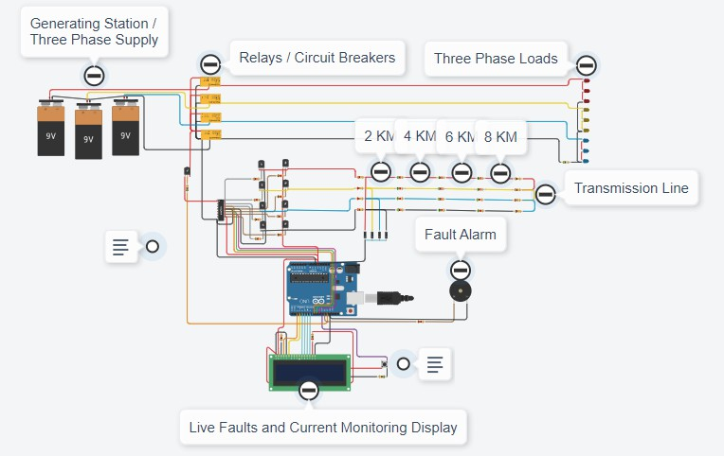

TinkerCAD circuit design with Arduino Uno The diagram below shows the C++ code we used for the circuit.

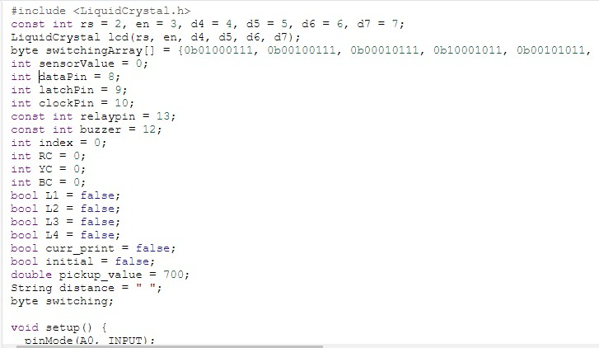

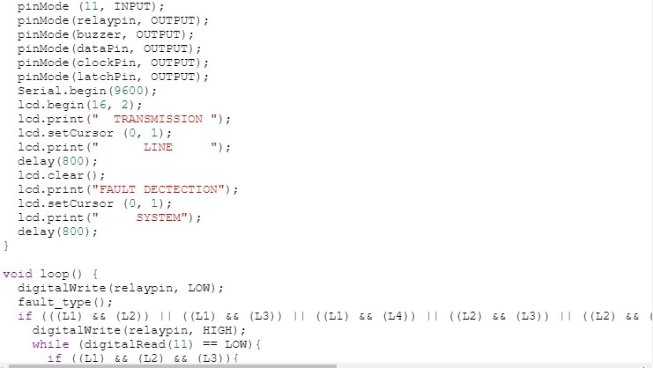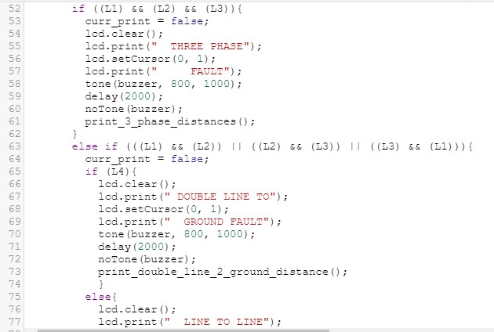

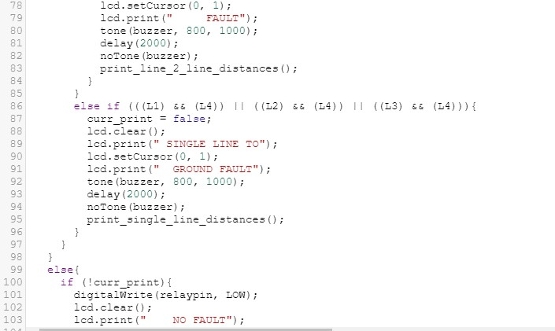

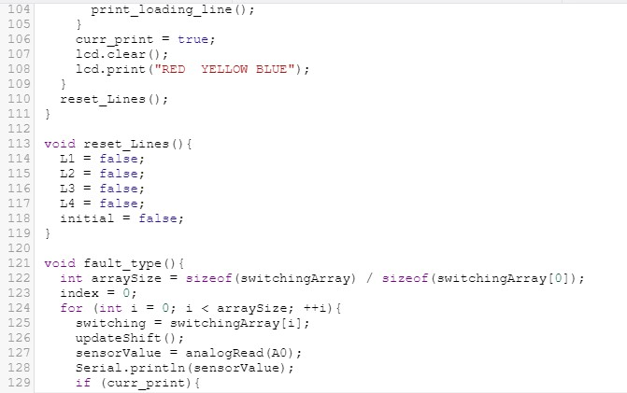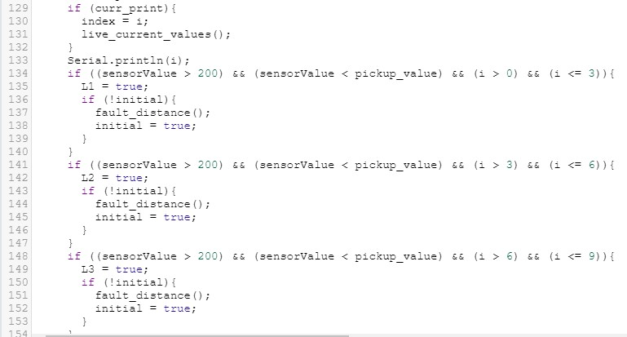



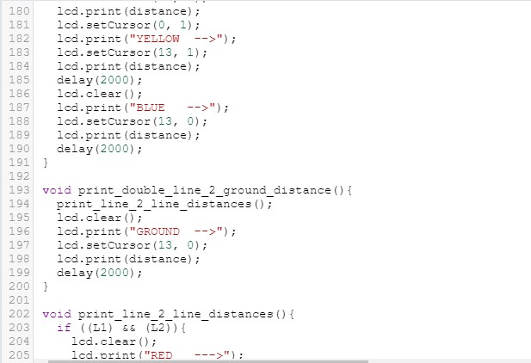

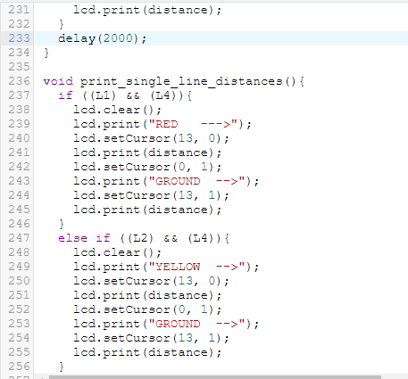

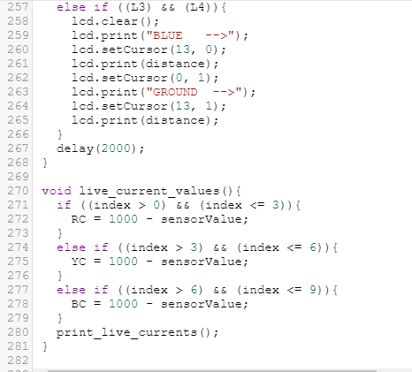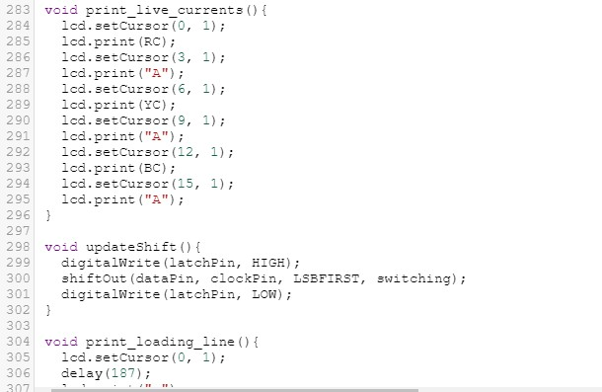

After validating the circuit design on TinkerCAD, we proceeded to create the physical circuit as shown below.

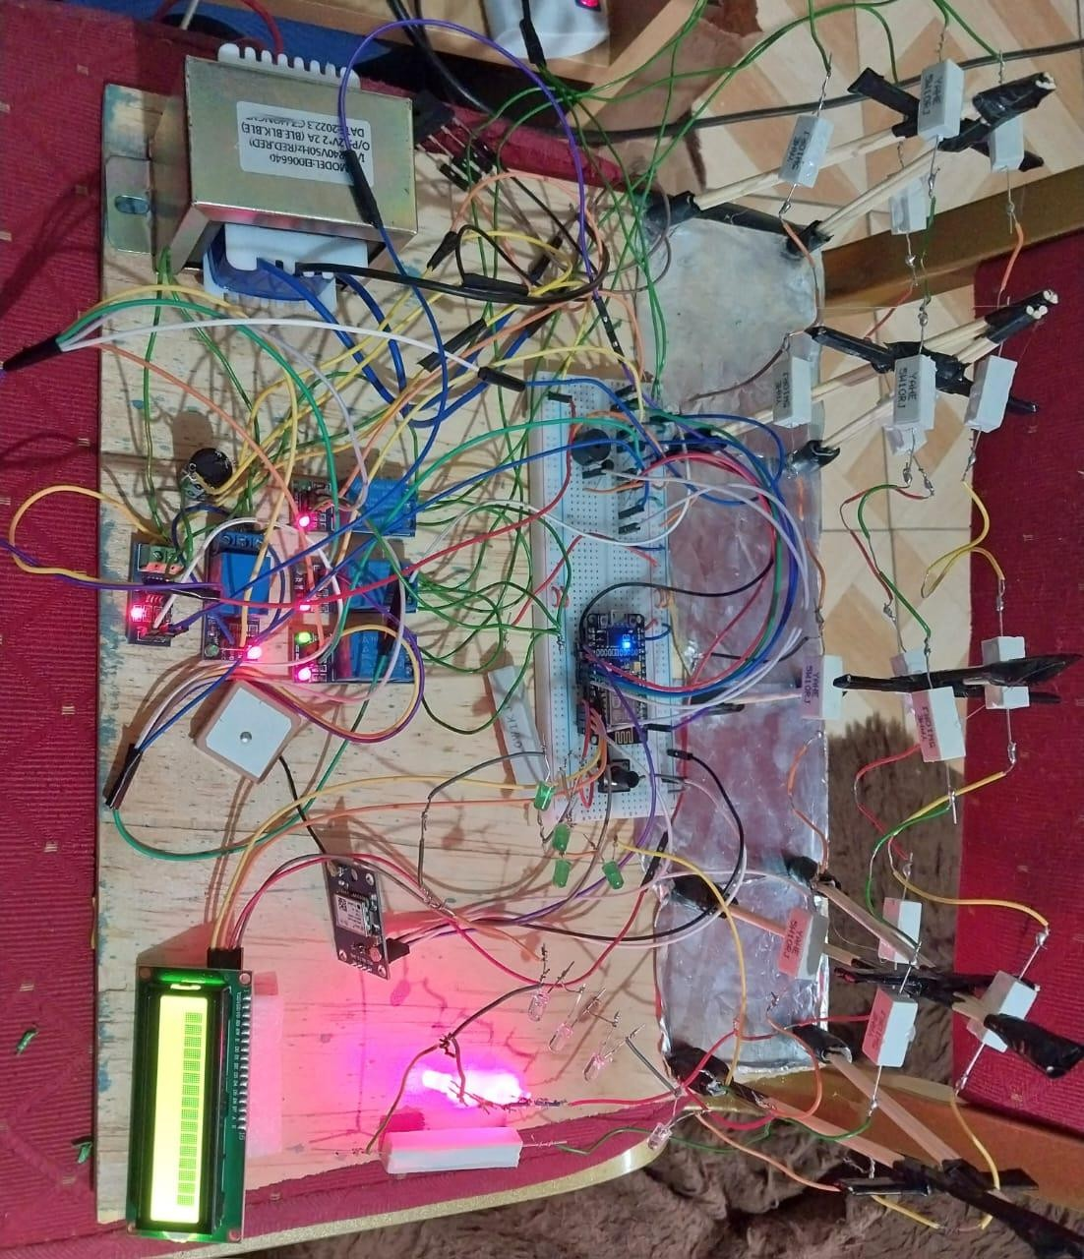

Physical system of the three-phase fault detection and classification model

### Model Creation, Evaluation and Saving

After validating the circuit’s functionality on TinkerCAD, we created two models, an Artificial Neural Network (ANN) model for fault detection and a decision tree classifier model for classification.

Three-Phase Fault Detection Model

The code below from Jupyter Notebooks shows the process we followed to preprocess data, create the model, train the model, and validate it.

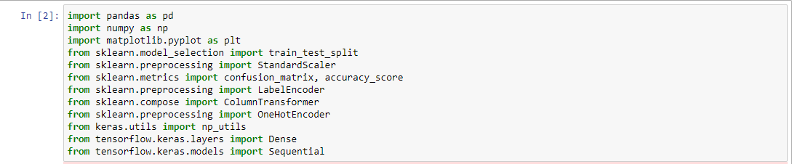

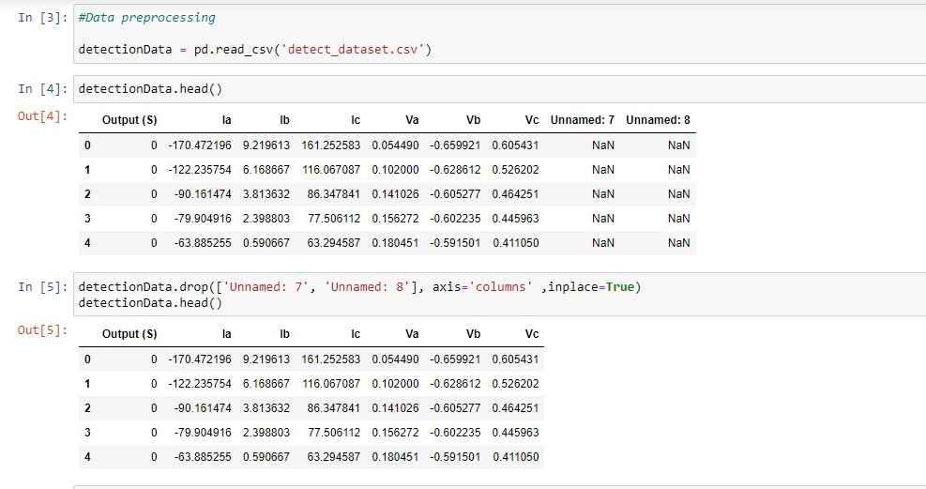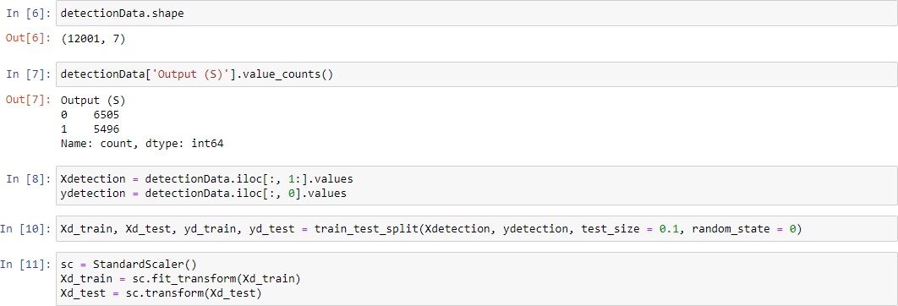

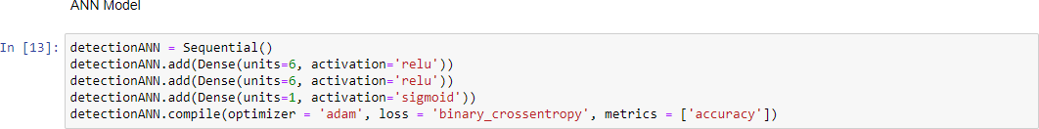

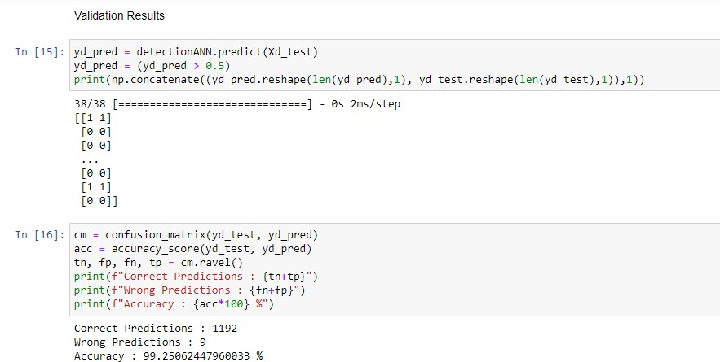

The diagram above shows that the ANN model achieved an accuracy of 99%

### Three-Phase Fault Classification Model using Decision Tree Algorithm

After creating the fault-detection model, we created a Decision Tree classifier for three-phase fault classification. The code below shows the steps we followed.

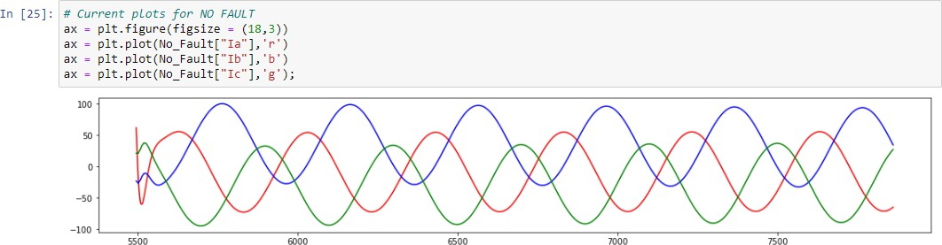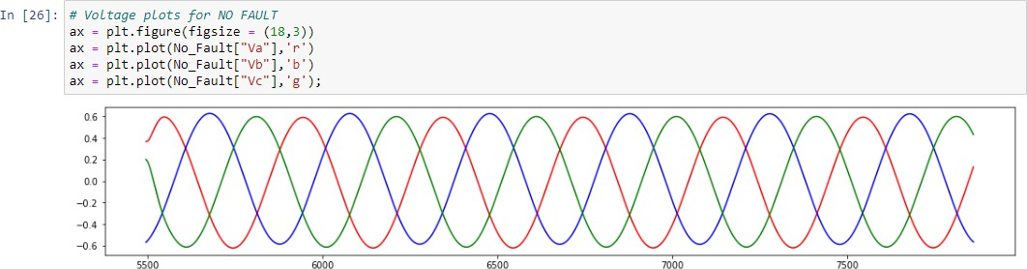

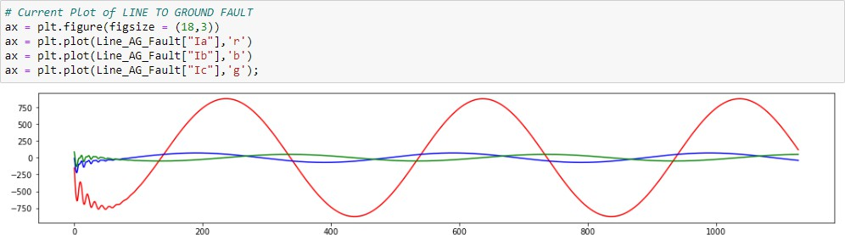

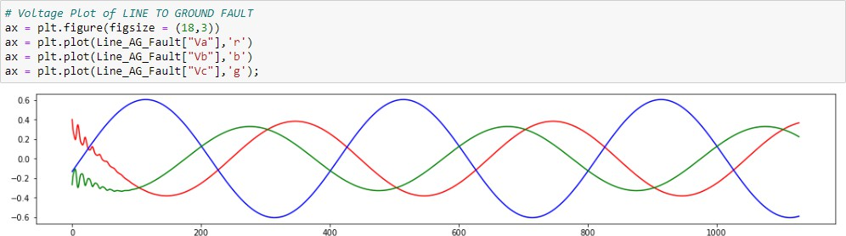

In Line A to ground fault the current in line A increases 10-fold to approximately 1000 Amperes from the normal 100 Amperes and Voltage reduces.

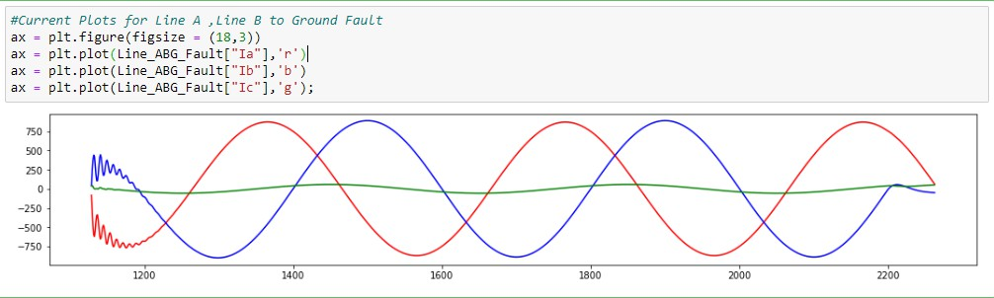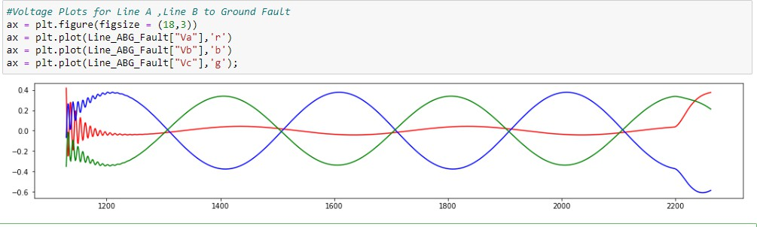

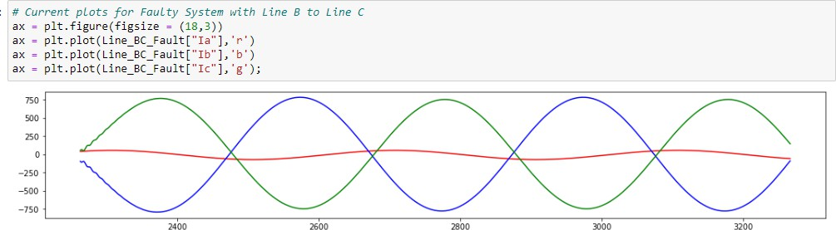

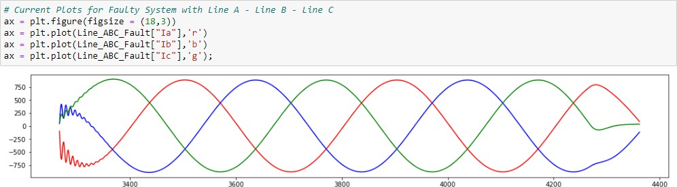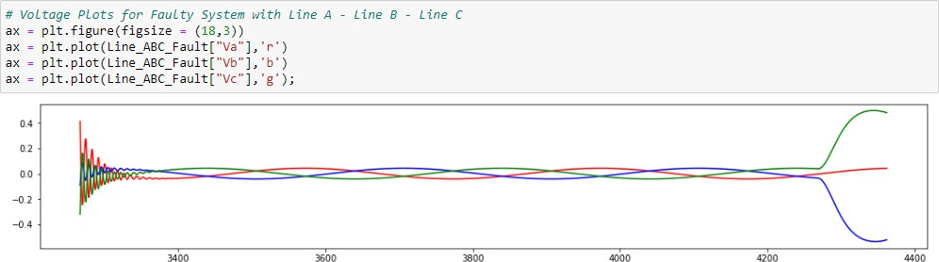

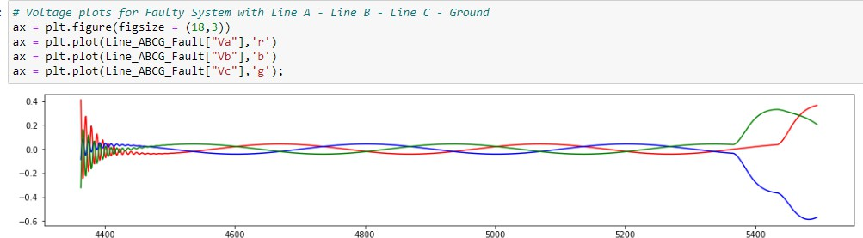

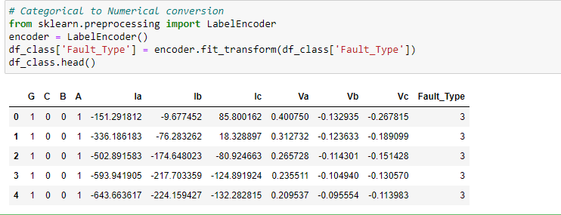

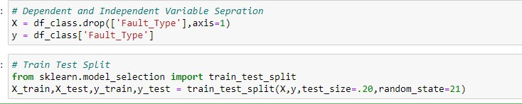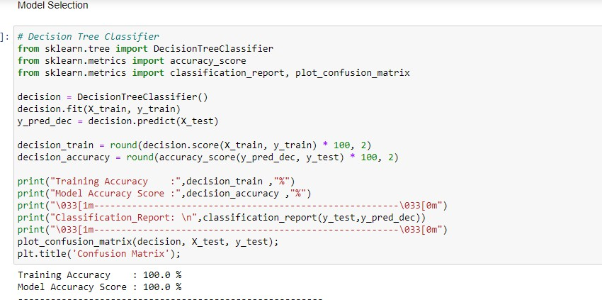

The validation results shown above proved that the model would perform well in the classification. After that, we saved the model for future use.

* + 1. **Deploying the Model**

The first step of the proposed system involves the systematic collection of data pertaining to partial discharge events. The project will leverage a publicly available database

acquired from power lines with a new meter designed at the Technical University of Ostrava. The dataset constitutes 20,388 partial signal waveforms.

* + 1. **Android Application**

After deployment, we followed an online tutorial to create an Android application using a real-time Firebase database provided by the site. The application should show the currents flowing through the phases and any faults that occur in the system. A screenshot of the application’s interface is shown below.

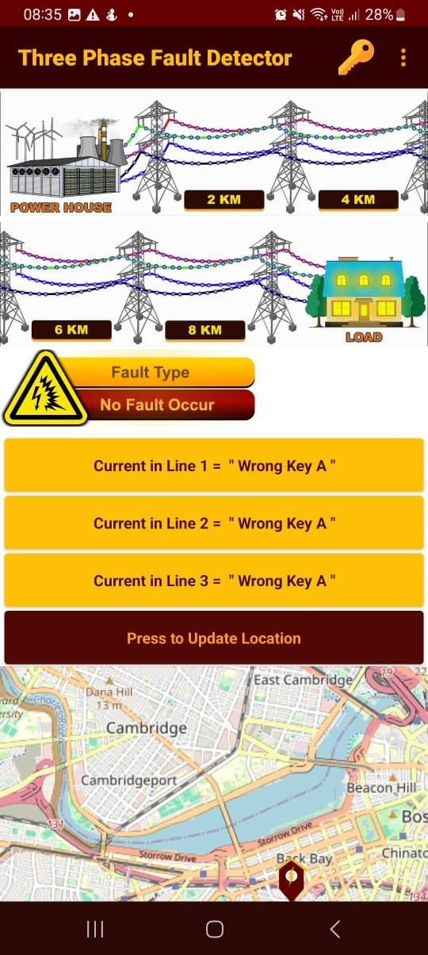

*The Display app without current and fault inputs from the phases*

* + 1. **Proposed System Diagram**

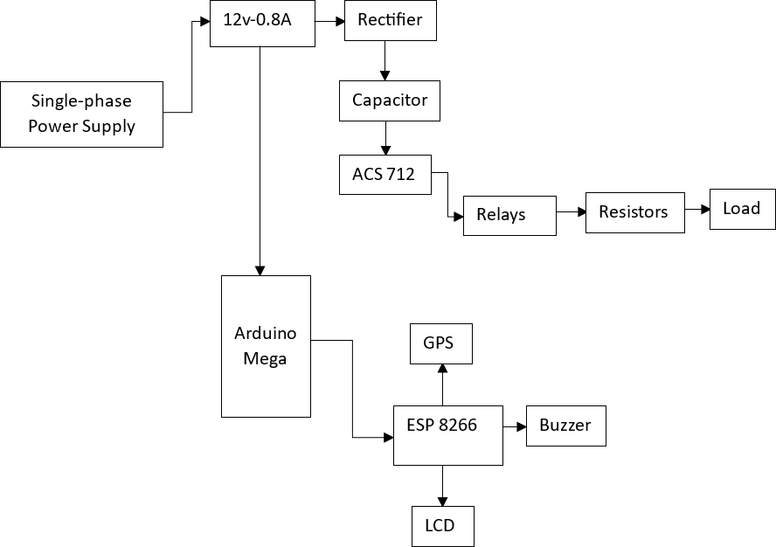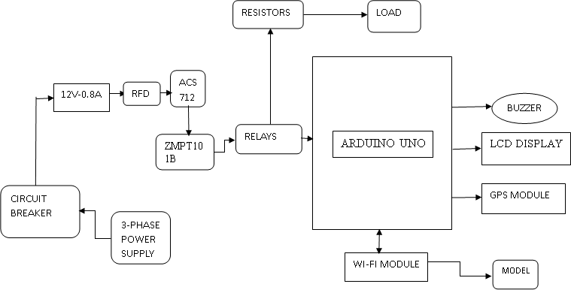

*Figure 3.1. Proposed system diagram*

### Hardware

Given the extensive scope of the project, the idea is to construct a single physical prototype, with the capabilities to simulate the different aspects of the system.

Complementary to the DL model used are several hardware components that will form part of

the physical system. The following list shows the proposed hardware components for this project work:

* Arduino MEGA
* 1 x Step-down transformer (12v, 800mA)
* Three-Phase Power Supply
* 1 x ACS712 Current Sensors
* 4 x 1 Channel Relay Modules
* 16 x 10Ω 5-Watt Resistors (for making transmission lines): 4 Resistors for each line
* 16 x 2 LCD Display
* LEDs (used as load)
* Push button (for resetting relays)
* Wi-Fi Module
* GPS Module
* 5V Piezo Buzzer (for fault alerts)

# CHAPTER FOUR

## EXPECTED RESULTS AND DISCUSSION

Data from the three voltage sensors and three current sensors connected to each phase will be collected and sent to the local server for anomaly detection using ANN. Anomaly detection will rely on voltage and current values in the phases under different conditions.

Line to Line, Line to Ground, Double Line to Ground, and Three Phase faults display recognizable patterns that the ANN can be trained to detect.



As seen in the diagrams above, the currents increase by a factor of 7.5 when there is a fault between a line and the ground.

The ANN model and decision tree classifier were trained on data that includes changes in current when different types of faults occur. The two models learned these current patterns and used them to predict the availability of faults in new current values fed from the three phases and ground. The diagram below shows the output from the ANN model and the decision tree classifier.

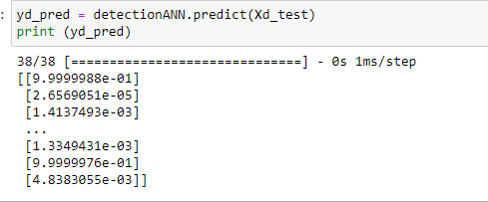



*Accuracy of the ANN model*

The decision tree classifier achieved an accuracy of 100% as shown below.

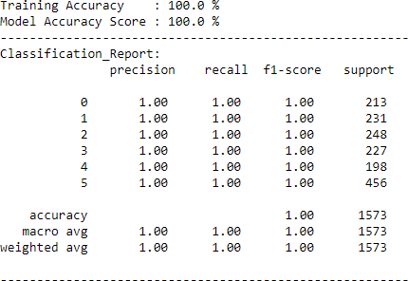

The confusion matrix below shows that 100% of the instances were correctly classified.

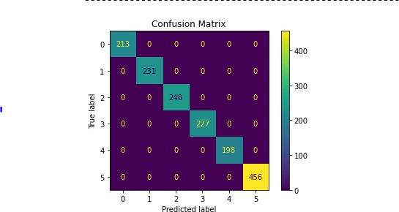

*Confusion Tree of the decision tree classifier model*

TinkerCAD was used to simulate the functionality of the system. However, TinkerCAD doesn’t have an ESP8266 element. Therefore, an Arduino Uno was used to simulate the current patterns. The TinkerCAD simulation with Arduino continuously displayed all current values and simulated faults as shown in the diagrams below.

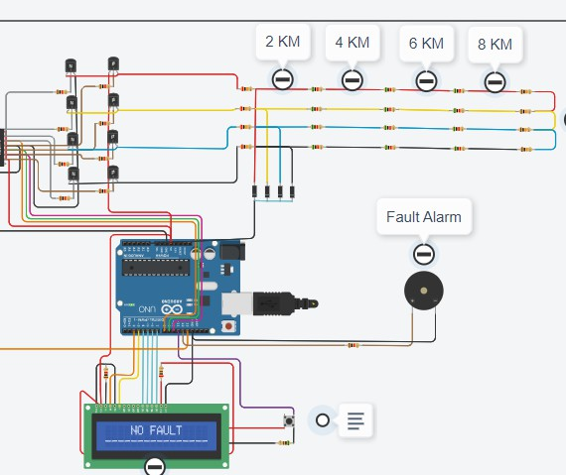

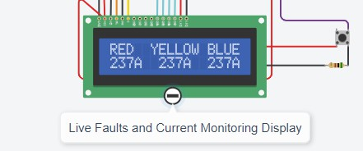

The diagram below is that of a Line to Line fault. It’s the result of a short circuit between the Red and Yellow lines.

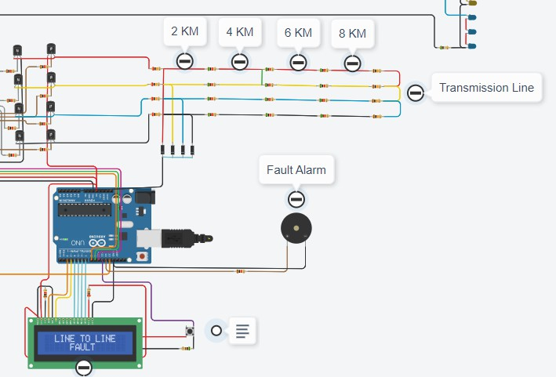

After displaying the type of fault, the system then displays the fault distances in the faulty lines. The diagram below shows a distance of 4km for both the red and yellow phases.

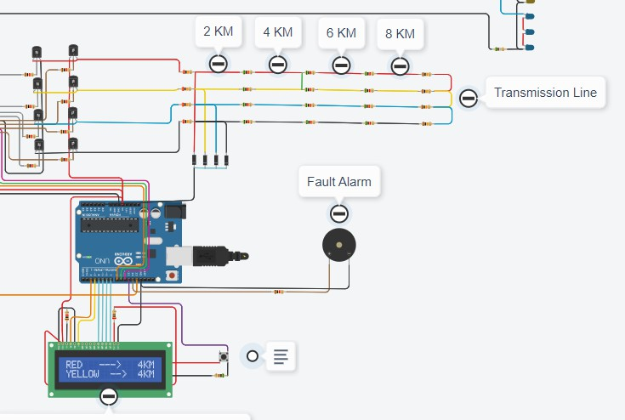

The diagram below displays a three-phase fault and the diagram after shows the fault distances and phases.

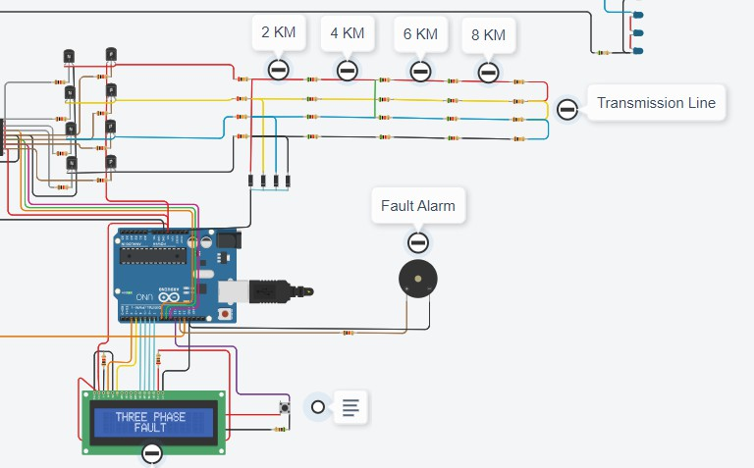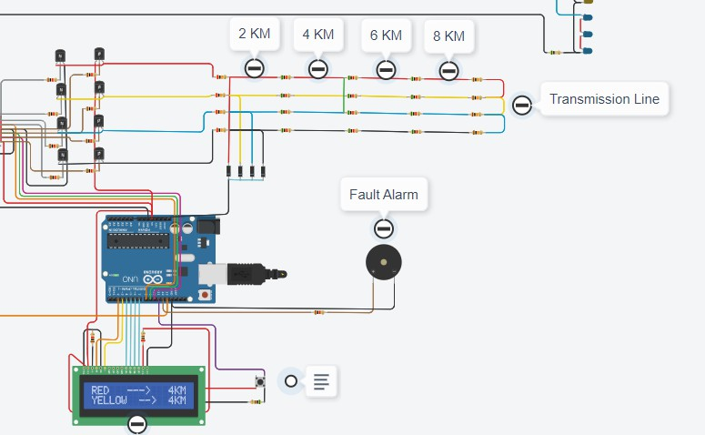

The TinkerCAD screenshot below displays a single line to ground fault and the diagram after shows the faulty phases and the fault distances.

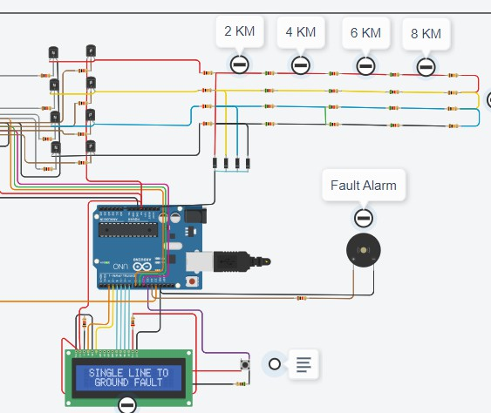

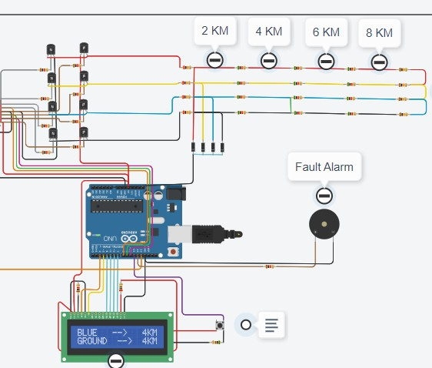

## CONCLUSION

In conclusion, this research project has undertaken a comprehensive exploration of the fault detection and adaptive control mechanisms within single-phase power transmission systems, addressing critical challenges and paving the way for transformative advancements. The current state of fault detection methodologies, marked by deficiencies in precision and adaptability, poses significant threats to the stability and resilience of power transmission networks. The adoption of advanced machine learning techniques, notably Artificial Neural Networks (ANNs) and Decision Tree Classifiers, represents a strategic intervention to enhance fault detection precision. Integrating these models into a real-time monitoring application using Flask facilitates enhanced responsiveness, enabling the timely identification and mitigation of faults in diverse operational scenarios. Simultaneously, the project has shed light on the challenges faced by traditional adaptive control strategies, especially those incorporating relay switches. The intricacies of optimizing responses to various fault types are vital for maintaining the stability and reliability of power transmission networks. The research has justified its focus on fault detection and adaptive control by recognizing the direct link between these aspects and the system's ability to adapt swiftly to evolving operational conditions. The growing complexities and interdependencies within modern power systems necessitate innovative solutions to address vulnerabilities arising from diverse fault scenarios. Moreover, the deployment of machine learning models onto resource- constrained devices, such as the ESP8266 using TensorFlow Lite, demonstrates a pragmatic approach to addressing scalability challenges in real-world power systems. This deployment strategy ensures that the proposed solutions are not only innovative but also applicable and feasible, considering the practical constraints often encountered in operational power transmission networks. In summary, this research project, by strategically integrating advanced machine learning models, developing real-time monitoring applications, and deploying solutions on resource-constrained devices, has laid the foundation for significant advancements in fault detection and adaptive control within single-phase power transmission systems. The outcomes of this research hold the potential to revolutionize the precision, responsiveness, and safety of power transmission networks, contributing to the overall reliability and resilience of critical energy infrastructure. As the energy landscape continues to evolve, the insights gained from this project will serve as a cornerstone for future developments in the field, ensuring the continued efficiency and sustainability of power transmission systems.

# REFERENCES

1. N. Hatziargyriou, “Frontiers in smart grids,” *Frontiers in Smart Grids*, vol. 1, 2022. https://doi:10.3389/frsgr.2022.986178
2. “Achieving resiliency by eliminating common mode failures in the smart grid,” 2012 *IEEE PES Innovative Smart Grid Technologies (ISGT),* 2012. https://doi:10.1109/isgt.2012.6175609
3. A. M. Gaouda, “Adaptive partial discharge monitoring system for future smart grids,” *IECON 2013 - 39th Annual Conference of the IEEE Industrial Electronics Society*, 2013. https://doi:10.1109/iecon.2013.6699942
4. H. Golmohamadi, R. Keypour, and M. Niasati, “Composite system maintenance coordination in a smart grid considering demand response,” *Technology and Economics of Smart Grids and Sustainable Energy*, vol. 1, no. 1, 2016. https://doi:10.1007/s40866-016-0014-1
5. T. AĞIR, “Using machine learning algorithms for classifying transmission line faults,” *DÜMF Mühendislik Dergisi*, 2022. https://doi:10.24012/dumf.1096691
6. A. Jain, A. S. Thoke, and R. N. Patel, “Classification of single line to ground faults on double circuit transmission line using ann,” *International Journal of Computer and Electrical Engineering*, pp. 197–203, 2009. https://doi:10.7763/ijcee.2009.v1.30
7. R. Rastgoufard, I. Leevongwat, and P. Rastgoufard, “Automatic determination of fault current breakpoint locations for personnel protective grounding of distribution and transmission lines,” *2015 Clemson University Power Systems Conference (PSC),* 2015. https://doi:10.1109/psc.2015.7101717
8. Rivas, A. E. L., & Abrao, T. (2020). Faults in smart grid systems: Monitoring, detection and classification. *Electric Power Systems Research*, *189*, 106602.
9. Shi, X., Qiu, R., He, X., Ling, Z., Yang, H., & Chu, L. (2020). Early anomaly detection and localisation in distribution network: A data‐driven approach. *IET Generation, Transmission & Distribution*, *14*(18), 3814-3825.
10. Sharma, G., Mahela, O. P., Kumar, M., & Kumar, N. (2018, June). Detection and Classification of Transmission Line Faults Using Stockwell Transform and Rule Based Decision Tree. In *2018 International Conference on Smart Electric Drives and Power System (ICSEDPS)* (pp. 1-5). IEEE.
11. El Chamie, M., Lore, K. G., Shila, D. M., & Surana, A. (2018, May). Physics-based features for anomaly detection in power grids with micro-pmus. In *2018 IEEE International Conference on Communications (ICC)* (pp. 1-7). IEEE.
12. Silva, K. M., Souza, B. A., & Brito, N. S. (2006). Fault detection and classification in transmission lines based on wavelet transform and ANN. *IEEE Transactions on power delivery*, *21*(4), 2058-2063.
13. Müller, S. C., Häger, U., & Rehtanz, C. (2014). A multiagent system for adaptive power flow control in electrical transmission systems. *IEEE Transactions on Industrial Informatics*, *10*(4), 2290-2299.
14. Duenas-Osorio, L., & Vemuru, S. M. (2009). Cascading failures in complex infrastructure systems. *Structural safety*, *31*(2), 157-167.
15. Pierre, D. A. (1987). A perspective on adaptive control of power systems. *IEEE Transactions on power systems*, *2*(2), 387-395.
16. Krishnanand, K. R., Dash, P. K., & Naeem, M. H. (2015). Detection, classification, and location of faults in power transmission lines. *International Journal of Electrical Power & Energy Systems*, *67*, 76-86.
17. Wang, Q., & Wang, Z. (2019, July). Research on Deploying the Deeplearning Models with Embedded Devices. In *2019 IEEE 9th Annual International Conference on CYBER Technology in Automation, Control, and Intelligent Systems (CYBER)* (pp. 1337-1341). IEEE.
18. Banos, O., Villalonga, C., Damas, M., Gloesekoetter, P., Pomares, H., & Rojas, I. (2014). Physiodroid: Combining wearable health sensors and mobile devices for a ubiquitous, continuous, and personal monitoring. *The Scientific World Journal*, *2014*.